Assignment : Implement the user story ingestion process by following the same approach used for test cases. Read the user story Excel file from the "src/data" folder, ingest the data into MongoDB, and create the user story vector index using the "user- stories-vector-index.json" configuration file available in the "src/config" folder.

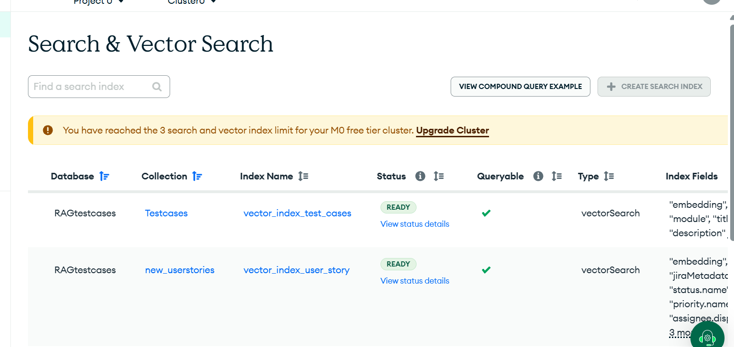

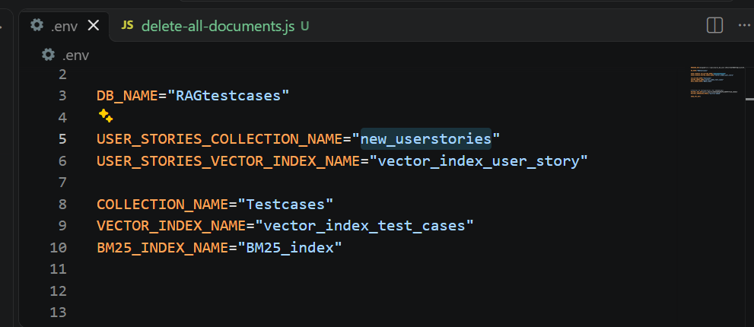

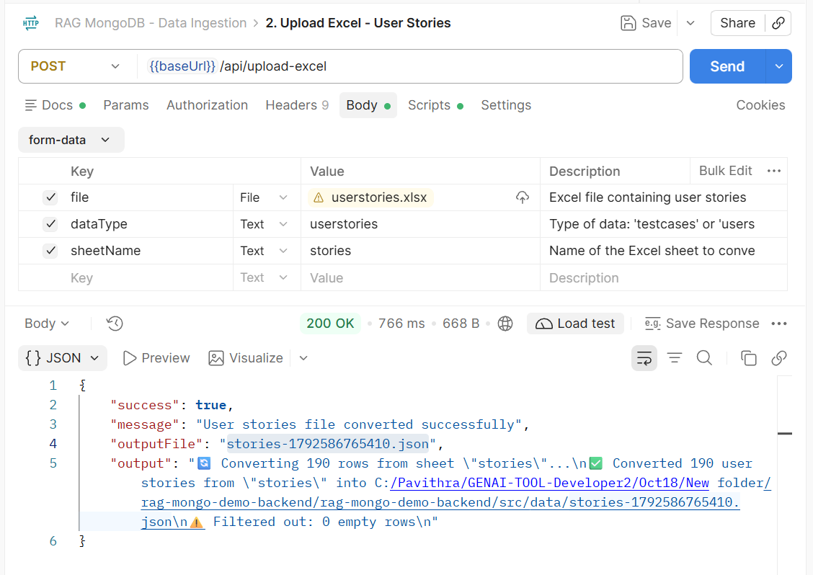

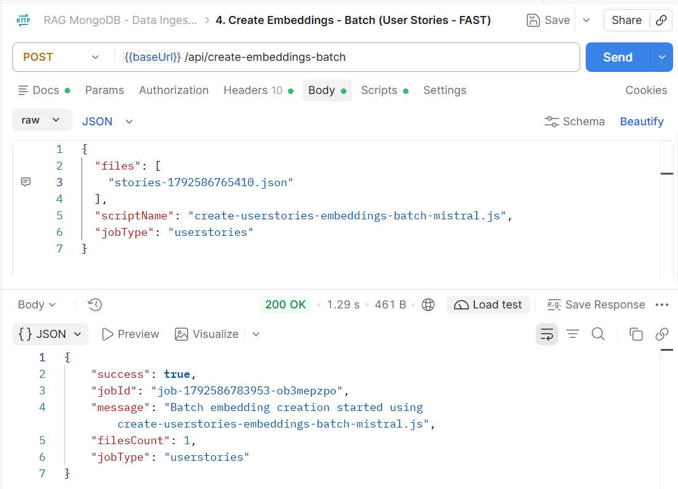

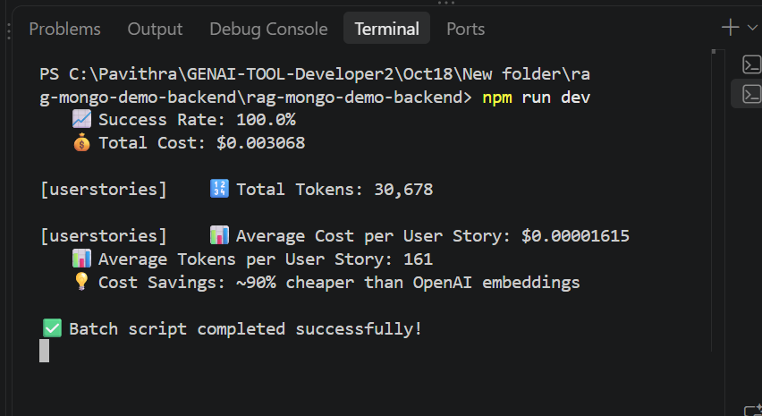

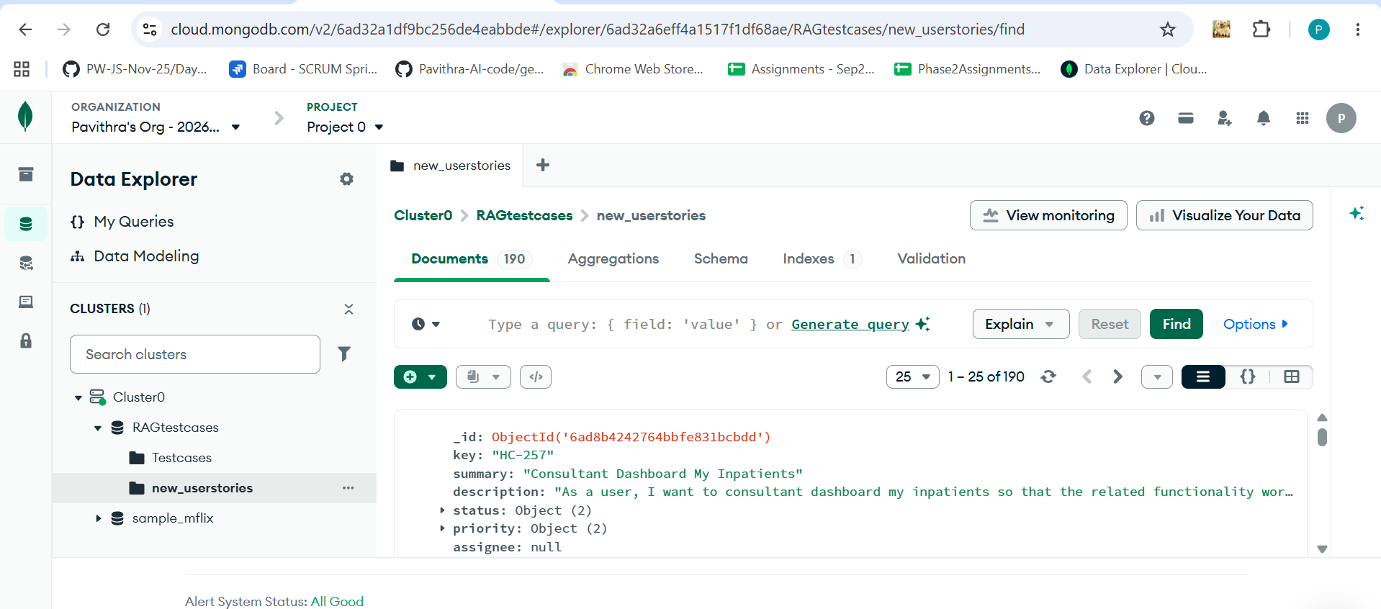

Delete userstories from DB:
